Academic Year: 2025-26 | Year: Second Year | Semester: II
PRN No.: 1012411011 | Name: Riddhee Kulkarni
Subject: Python Programming
Assignment No.: 20
Date: 16/03/2026

Lab Assignment: 20
Aim:
To write a Python program to generate an Abecedarian series from a list of words.

Objective:
- To understand the concept of Abecedarian words.
- To implement a Python function to check whether letters in a word appear in alphabetical order.
- To display all Abecedarian words from user input.

Theory:
An Abecedarian word is a word in which the letters appear in alphabetical (dictionary) order. The letters may repeat, but they should never appear in decreasing alphabetical order.
Example:
- "almost" → Abecedarian (a < l < m < o < s < t)
- "hello" → Not Abecedarian (since l comes after e, but e appears again later)
In Python, we can check this by:
- Converting the word into a list of characters.
- Sorting the characters alphabetically using sorted().
- Comparing the original list with the sorted list.
If both are the same, the word is Abecedarian.

Algorithm:
- Start the program.
- Define a function is_abecedarian(word).
- Convert the word into a list of characters.
- Sort the list using sorted().
- Compare the original list with the sorted list.
- If both are equal, return True, otherwise return False.
- Accept words from the user separated by space.
- Split the input into a list of words.
- For each word, call the function is_abecedarian().
- If the function returns True, print the word.
- Stop the program.

Pseudo Code:
START

DEFINE function is_abecedarian(word)
IF list(word) == sorted(word)
RETURN True
ELSE
RETURN False

INPUT words separated by space
SPLIT input into list of words

PRINT "Abecedarian words are:"

FOR each word in list
IF is_abecedarian(word)
PRINT word

END

Code:
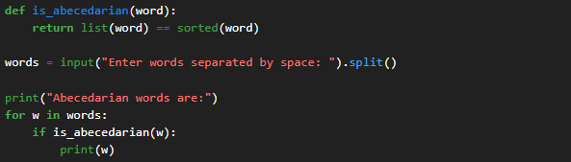

Output:
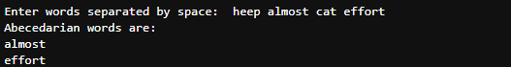

Conclusion:
Thus, the Python program was successfully implemented to identify and display Abecedarian words, where the letters in each word appear in alphabetical order.

